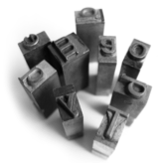
Swarthmore College Writing Center
writing.swarthmore.edu
610.328.8659
Stumped? Questions to Ask When Constructing a Thesis

From David Rosenwasser, Jill Stephen, and Doug Babington, Writing Analytically, Toronto: Thomson Nelson, 2006.
ted from They Say, I Say: The Moves that Matter in Academic Writing by Gerald Graff and Cathy Birkstein (2006).
- What kinds of patterns or implications emerge when I look closely at my evidence?

- What kind of evidence and support do I need to support my tentative thesis?

- What kind of evidence cannot be adequately accounted for by my tentative thesis?

- How can I explain the mismatches between my thesis statement and my selected evidence?

- How can I rewrite my thesis statement in order to accommodate the evidence that doesn't fit?

